2015 Empowering Today’s Accountant Seminar
Desert Willow Conference Center - Phoenix, AZ
Friday August 28, 2015
Registration Form

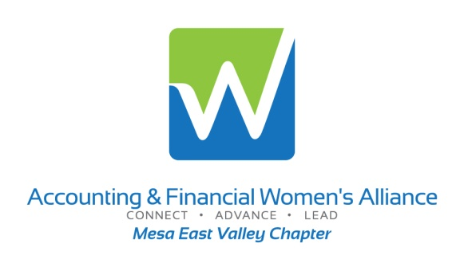

Regular Early
Registration Registration

AFWA / IMA Member Registration: $150 $125
Other Association Registration: $200 $175
Regular Registration: $250 $225
Student Registration: $25 $25

Early Registration Deadline: July 31, 2015 Final Registration Deadline: August 21, 2015

__________________________ _ _________________ ___________
Name Company
____________________________________ ___________________________________
Address Title
__________________________ _________ ___________________________________
Email
____________________________________ ___________________________________
Phone

Please include email address. Confirmation emails will be sent prior to event. Space is limited.

Please make checks payable to AFWA and mail with completed registration form to:

AFWA P.O. Box 41294 Mesa, AZ 85274 AFWA Tax ID # 86-0545075

If you are unable to attend, you may send a colleague in your place. Refunds will only be issued for reservations canceled prior to the final registration due date. For more information regarding administrative policies, please contact AFWA Mesa East Valley Chapter Seminar Chair, Laura Mangan at chapter@mesaeastvalleyafwa.org or call 480-276-5926.

Online registration and credit card payment option available at www.mesaeastvalleyafwa.org/seminars.

